Technical Architecture Document: Agentic AI-Powered Career Opportunity Recommendation System

Architectural Assumptions and Foundational Design Principles
Translating the conceptual High-Level Design (HLD) of the AI-Powered Career Opportunity Recommendation System into a production-ready technical specification requires establishing concrete architectural assumptions where operational parameters remain open-ended. The system is engineered for a moderate-scale production deployment supporting 10,000 to 100,000 monthly active candidates and processing 500,000 to 2,000,000 active opportunity listings. In accordance with the core architectural mandate, the design rejects hyperscale microservice sprawl and distributed event-mesh complexity in favor of a modular, service-oriented monolith backed by asynchronous background workers.
To balance interactive responsiveness with deep market research, the architecture establishes a dual-path execution service-level agreement (SLA): synchronous recommendation generation completes within an upper boundary of 8,000\text{ ms} when leveraging warm cache layers, whereas cold-start profile ingestion requiring live external market discovery operates asynchronously via streaming server-sent events (SSE) with a hard timeout boundary of 30,000\text{ ms}. To satisfy the requirement for offline AI capability alongside optional cloud scalability, all agent nodes interface through a unified AI Provider Abstraction Layer powered by LiteLLM and local Ollama model runners, ensuring zero vendor lock-in while acknowledging that live external opportunity discovery requires active network egress or pre-hydrated local snapshots. Furthermore, because the platform must seamlessly support internships, full-time engineering roles, apprenticeships, and fellowships without structural refactoring, all data schemas and validation pipelines utilize a polymorphic opportunity domain model paired with standardized international occupational taxonomies—specifically the European Skills, Competences, Qualifications and Occupations (ESCO v1.2.1) classification and O*NET Web Services v2.0. Finally, the architecture enforces a strict boundary between probabilistic language model generation and deterministic software engineering: hard eligibility filtering, mathematical score aggregation, schema validation, and database mutations are executed exclusively by deterministic code paths, preventing language models from inventing ranking scores or overriding mandatory compliance constraints.

1. System Architecture and State Machine

1.1 Agentic Workflow Pattern Selection
Contemporary agentic system design distinguishes sharply between prescriptive workflows—where language models and tools execute along predefined code paths—and autonomous agents, where models dynamically direct their own control flow, tool usage, and iteration boundaries. A rigid prompt-chaining or sequential pipeline is structurally inadequate for career opportunity recommendation because the required analytical subtasks cannot be predicted at compile time. For instance, if a candidate's resume lacks verifiable evidence for a claimed core competency, or if an initial opportunity query for a primary target role yields zero eligible listings after deterministic filtering, a static chain cannot dynamically branch to interrogate GitHub commit histories or expand discovery into adjacent occupational taxonomies. Conversely, an unconstrained autonomous swarm introduces unacceptable latency, non-deterministic scoring drift, and vulnerability to infinite execution loops.
To resolve this tension, the architecture implements a composite Hierarchical Orchestrator-Workers (Supervisor) Pattern with Dynamic Map-Reduce Fan-Out and Bounded Evaluator-Optimizer Loops. At the apex of the hierarchy, the Recommendation Orchestrator Agent functions as a stateful supervisor node. Rather than executing domain extraction directly, the Orchestrator evaluates the current state contract, determines which specialized analyses are required, delegates execution to five domain-specific worker subgraphs, and evaluates the consolidated evidence against concrete sufficiency thresholds. This separation of concerns eliminates cognitive overload on any single model instance while preserving centralized governance over iteration budgets and fallback trajectories.
Architectural Pattern Layer | Assigned System Components | Execution Mechanism & Control Flow | Architectural Justification
Hierarchical Supervisor (Orchestrator-Workers) | Recommendation Orchestrator Agent directing the 5 specialized AI agents. | Central supervisor inspects global state, emits routing commands, and synthesizes worker outputs via return-to-supervisor edges. | Eliminates cognitive overload on a single LLM prompt and enables dynamic runtime planning when data is missing or stale.
Parallel Sectioning & Map-Reduce (Send API) | User & Career Profile Agent, Market Intelligence Agent, Opportunity Discovery & Validation Agent. | Orchestrator dispatches independent worker nodes concurrently; Discovery dynamically spawns N parallel worker instances across target and adjacent career paths using LangGraph's Send primitive. | Eliminates sequential latency bottlenecks when researching multiple career paths or validating dozens of scraped listings simultaneously.
Deterministic Gate (Programmatic Chaining) | Deterministic Eligibility Subsystem. | Pure Python/SQL rule engine placed as a mandatory programmatic gate between Discovery/Validation and Recommendation/Ranking. | Guarantees 100\% compliance with hard eligibility constraints (e.g., graduation dates, work authorization) before any probabilistic ranking occurs.
Bounded Evaluator-Optimizer Loop | Recommendation & Ranking Agent + Recommendation Explanation Agent + Orchestrator Critique. | Ranking and Explanation outputs are audited against structured provenance criteria; failures trigger targeted regeneration with explicit feedback up to a strict iteration cap. | Prevents hallucinated explanations and ensures every recommended opportunity is backed by verifiable skill and market evidence.

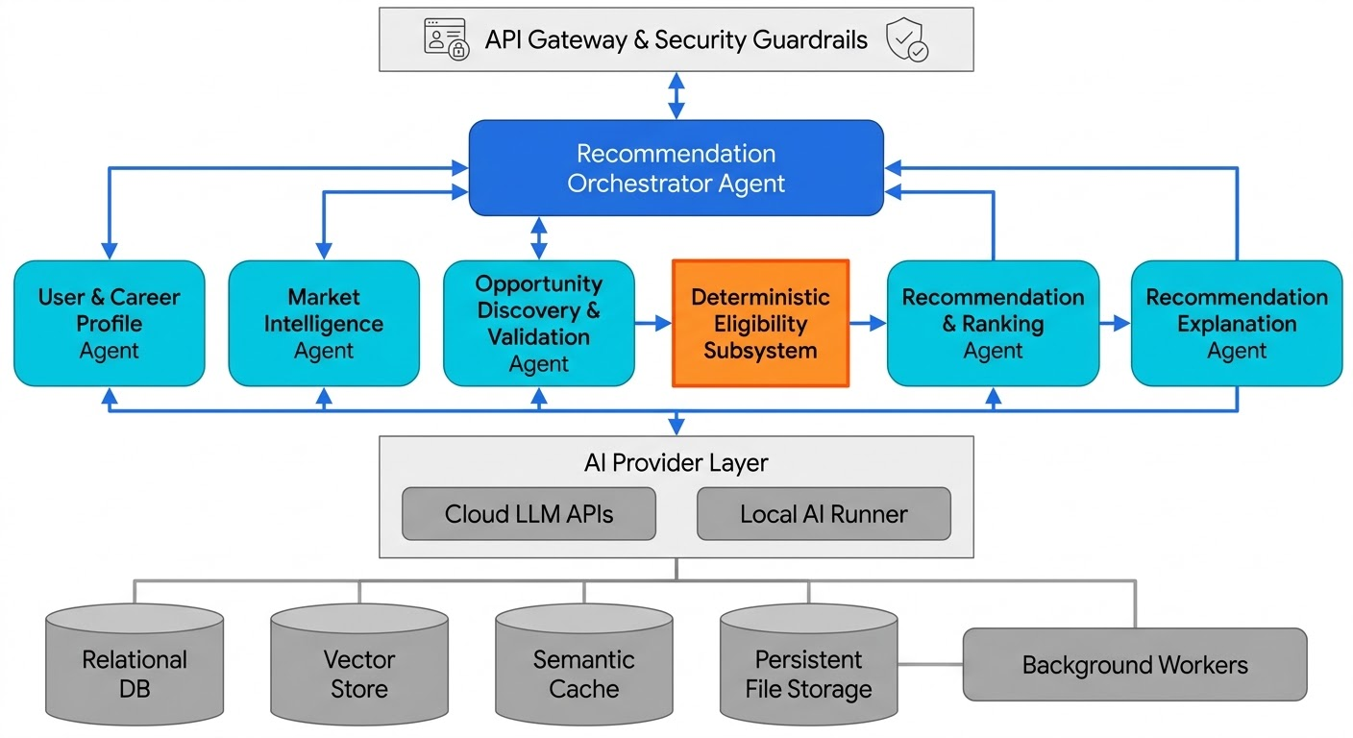1.2 Formal State Machine Specification
To coordinate multiple specialized agents around shared state without race conditions or state corruption, the system models the workflow as a compiled StateGraph. In this paradigm, state serves as a strict typed contract where nodes never mutate state in place; instead, every node receives the current state snapshot and returns a partial dictionary containing only updated keys. When parallel nodes execute simultaneously—such as concurrent MarketIntelligenceAgent workers researching primary and adjacent career paths—attempting to overwrite the same state key raises an InvalidUpdateError. Consequently, every accumulating state channel is annotated with a pure binary reducer function (left: CurrentValue, right: NodeUpdate) -> MergedValue that deterministically merges concurrent updates. Ephemeral node-scoped variables are prefixed with an underscore (e.g., _raw_scrape_buffer) to signal that they must be stripped at superstep boundaries, while explicit Overwrite wrappers are reserved for full state resets during trajectory pivots.
State Identifier | Responsible Component | Entry Action & Processing Logic | Outbound Transition Condition | Boundary Condition & Hard Limits
S0_INIT_AND_AUTH | API Gateway & Input Guardrail | Authenticate user, generate deterministic thread_id = uuid7(user_id + session_id)[:255], initialize StateGraph checkpoint, scan inputs for direct prompt injection. | Validated request payload and initialized state contract \rightarrow S1_ORCHESTRATOR_PLAN. Malicious input detected \rightarrow S9_TERMINAL_ABORT. | Max request payload: 10\text{ MB} (resume file); Auth/Guardrail timeout: 500\text{ ms}.
S1_ORCHESTRATOR_PLAN | Recommendation Orchestrator Agent | Inspect state contract, check cache version/TTL for user profile and market intelligence, formulate execution plan, and decrement remaining_steps budget. | Profile missing or unverified \rightarrow S2_PROFILE_ANALYSIS. Profile valid \rightarrow parallel fan-out (Send) to S3_MARKET_RESEARCH and S4_OPPORTUNITY_DISCOVERY. | max_orchestrator_loops = 4; Global workflow wall-clock timeout: 30,000\text{ ms}.
S2_PROFILE_ANALYSIS | User & Career Profile Agent | Parse resume/artifacts, extract skills, compute evidence-backed proficiency (1\text{–}10) and confidence (0.0\text{–}1.0), map current, target, and adjacent career paths via ESCO/O*NET, identify skill gaps. | Profile schema validated and overall confidence \ge 0.65 \rightarrow S1_ORCHESTRATOR_PLAN. Low confidence and supplemental sources available \rightarrow self-loop once. | max_profile_retries = 2; Node execution timeout: 6,000\text{ ms}.
S3_MARKET_RESEARCH | Market Intelligence Agent | Query Semantic Cache for target/adjacent career roles. On cache miss or stale TTL, query O*NET/ESCO and live job aggregations to compute skill demand weights and emerging trends. | Evidence-backed market report compiled (or degraded stale cache flagged) \rightarrow join barrier at S1_ORCHESTRATOR_PLAN. | max_parallel_careers = 4; Cache freshness TTL: 168\text{ hours} (7\text{ days}); Timeout: 8,000\text{ ms}.
S4_OPPORT[span_1](start_span)[span_1](end_span)UNITY_DISCOVERY | Opportunity Discovery & Validation Agent | Query vector/hybrid stores and permitted ATS feeds; normalize listings into polymorphic schema; run MinHash LSH deduplication; validate completeness, freshness, and trust signals. | Normalized, deduplicated candidate pool > 0 \rightarrow S5_ELIGIBILITY_FILTER. Pool empty \rightarrow return to S1_ORCHESTRATOR[span_2](start_span)[span_2](end_span)_PLAN for query expansion. | max_discovery_expansions = 2; Max raw listings evaluated per run: 250; Timeout: 10,000\text{ ms}.
S5_ELIGIBILITY_FILTER | Deterministic Eligibility Subsystem | Execute hard boolean rule checks (degree/enrollment status, visa/work authorization, location/work-mode hard constraints, active deadline \ge \text{ current\_date}). | Eligible pool count N_{\text{elig}} \ge K_{\text{min}} (default 5) \rightarrow S6_RANKING_EVAL. If N_{\text{elig}} < K_{\text{min}} and expansions remain \rightarrow S1_ORCHESTRATOR_PLAN (expand to adjacent paths). | Zero LLM calls allowed; Pure deterministic execution ceiling: 150\text{ ms}.
S6_RANKING_EVAL | Recommendation & Ranking Agent | Compute 6 structured dimensional scores for each eligible listing; combine with Reciprocal Rank Fusion (RRF) and weighted Multi-Criteria Decision Analysis (MCDA). | Ranked list deterministic audit passes (no NaN, bounds [0.0, 1.0], monotonic ordering) \rightarrow S7_EXPLANATION_SYNTHESIS. | Top M = 20[span_28](start_span)[span_28](end_span) candidates scored deeply; Node timeout: 4,000\text{ ms}.
S7_EXPLANATION_SYNTHESIS | Recommendation Explanation Agent | Generate personalized rationale for top K = 10 recommendations citing exact skill proficiency matches, target skill-gap closure, and market demand provenance. | Output passes S8_CRITIQUE_GATE faithfulness audit \rightarrow S9_TERMINAL_SUCCESS. Audit detects ungrounded claims \rightarrow regenerate with feedback. | max_explanation_rewrites = 2; Node timeout: 5,000\text{ ms}.
S8_CRITIQUE_GATE | Evaluator / Guardrail Node | Verify that generated explanations strictly reflect mathematical ranking signals and contain zero hallucinated qualifications or prompt injection artifacts. | Pass \rightarrow S9_TERMINAL_SUCCESS. Fail (retries remaining) \rightarrow S7_EXPLANATION_SYNTH[span_29](start_span)[span_29](end_span)ESIS. Fail (retries exhausted) \rightarrow Deterministic template fallback. | Evaluation latency ceiling: 1,500\text{ ms}; Strict schema conformance required.
S9_TERMINAL_SUCCESS / ABORT | Persistence & Response Formatter | Persist versioned recommendation snapshot to PostgreSQL and Redis cache, emit OpenTelemetry trace metrics, return structured payload to client. | Terminal state; workflow halts (END). | Checkpoint retention TTL: 30\text{ days} before automated pruning.

1.3 Context Window Management Across Long Execution Loops
Long-running multi-agent workflows frequently suffer from context window exhaustion, latency escalation, and attention dilution ("lost-in-the-middle" degradation) when raw tool outputs, scraped job descriptions, and multi-agent conversational histories accumulate across cyclic iterations. To maintain a lean, bounded token footprint across every execution loop, the architecture implements a four-tier context management protocol combining pointer-based state offloading, subgraph namespace isolation, token-threshold compaction, and dual-store persistence.
The first mechanism enforces a strict Claim-Check Pattern (pointer-based state offloading), wherein raw binary files, full-text resumes, and scraped HTML or JSON job postings are prohibited from entering the StateGraph message channel or checkpoint payloads. During ingestion and discovery, raw artifacts are written immediately to Persistent File Storage (S3/MinIO) or PostgreSQL document tables, while the graph state stores only lightweight UUID pointers, cryptographic content hashes, and structured Pydantic metadata summaries. This architectural discipline keeps serialized msgpack checkpoints (BYTEA) under 64\text{ KB} per superstep and prevents database serialization bloat.
The second mechanism relies on subgraph namespace isolation. Each of the five specialized agents is compiled as an isolated subgraph operating within its own checkpoint namespace (checkpoint_ns = "node_name:uuid"). When the MarketIntelligenceAgent or OpportunityDiscoveryAgent executes multiple internal tool calls, search pagination loops, and schema repair retries, those intermediate AIMessage and ToolMessage traces remain confined to the subgraph's private state (PrivateState). Upon completion, the subgraph returns only the validated OutputState schema to the parent Orchestrator graph, preventing worker scratchpad noise from polluting the supervisor's context window.
Within iterative agent nodes, the third mechanism deploys a pre-model middleware hook that monitors cumulative token usage prior to every language model invocation. If the local message history exceeds 75\% of the allocated node context budget—hard-capped at 16,000\text{ tokens} per worker node even when underlying models support 128\text{k+} windows to preserve inference speed and analytical precision—the system triggers deterministic state compaction. Using LangGraph's RemoveMessage tombstoning and DeltaChannel batch reducers, obsolete tool call sequences and failed validation turns are pruned in a single pass and replaced with a compact, structured state summary.
Finally, the fourth mechanism separates short-term thread execution state (AsyncPostgresSaver checkpointer) from long-term cross-thread user memory (PostgresStore). While the Store retains durable user profiles, historical feedback, and verified skill graphs indefinitely across sessions, thread checkpoints are compacted at superstep boundaries and purged via a scheduled nightly PostgreSQL cron job (DELETE FROM checkpoints WHERE created_at < NOW() - INTERVAL '30 days'), preventing unbounded storage growth across long-lived deployments.

